UNIVERSITY OF CALCUTTA

Topic: Federated Learning
M.SC Semester III
PAPER CODE: CSMP-306
SESSION: 2025-26
SUBMITTED BY: Debottam Kar
CU-ROLL: C91/CSC/241011
REGISTRATION NO: 313-1111-0359-21

Index

Topics Page No

Introduction: What is Federated Learning?
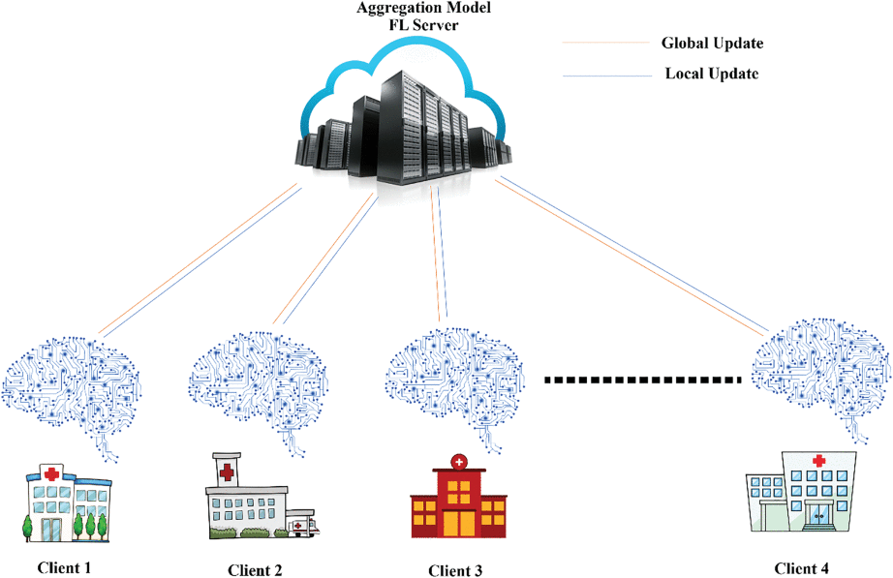
Healthcare has evolved significantly with the integration of technology, enabling processes like patient registration, remote monitoring, and self-care applications. The rise of the Internet of Medical Things (IoMT) has dramatically increased the volume of digital health data, and Artificial Intelligence (AI) is now used to analyze this data for applications like disease prognosis and personalized care.
However, this growth brings serious challenges around data privacy and security. Healthcare organizations handle vast amounts of sensitive patient information — medical records, diagnoses, treatment histories — and protecting this data from breaches has become a critical concern.
Deep learning (DL), a powerful branch of AI, plays a dual role in this landscape: it helps analyze patient data for disease diagnosis and treatment planning, while also strengthening cybersecurity defenses against threats and fraud in healthcare systems.
To address the tension between data utility and privacy, Federated Learning (FL) has emerged as a promising solution. Rather than centralizing raw patient data, FL trains machine learning models directly on decentralized sources — individual hospitals, clinics, or patient devices — and shares only model updates with a central server. This keeps sensitive data localized and secure. FL systems are built around three core components: client devices, a federated server, and a communication protocol.
In essence, the text frames federated learning as a natural response to the growing need for privacy-preserving AI in an increasingly data-driven healthcare environment.
Federated learning is a machine learning approach where multiple devices or organizations collaboratively train a shared model without sharing their raw data.
Instead of sending data to a central server, each participant:
- Downloads the current global model.
- Trains it locally on their own data.
- Sends only the updated model parameters (not the data) back to a central server.
- The server aggregates all updates to improve the global model.
- The process repeats.

Traditional Machine Learning vs Federated Learning
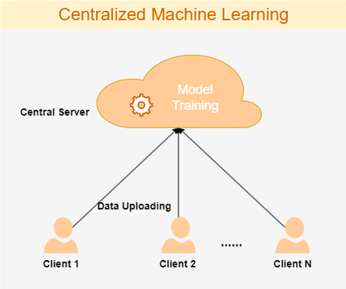
(1)
In traditional approaches, all data is collected in one place and used to train a
model.
- Data from multiple sources is sent to a central server
- The model is trained on this centralized dataset
- After training, the model is deployed
Example:
A company collects all user data (images, text, transactions) on its servers
and trains a model there.

Key Characteristics
- Centralized data storage
- Easier to manage and train
- Requires moving data to one location
- Higher risk of data breaches
- Huge Bandwidth usage(Huge data transfer)

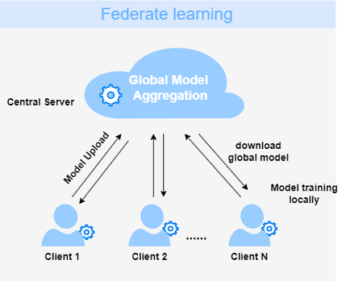
(2)
Federated learning trains a model across multiple devices without collecting raw data.
- Data stays on local devices (phones, hospitals, banks, etc.)
- Each device trains the model locally
- Only model updates (not data) are shared with a central server
- The server aggregates updates to improve the global model
Example:
Your phone improves a keyboard prediction model using your typing data—without sending your messages anywhere.

Key Characteristics
- Decentralized data
- Stronger privacy protection
- Data never leaves the device
- More complex training process

Federated Learning in depth
Core Idea
Instead of bringing data to the model, Federated Learning brings the model to the data.
- Each client (device/organization) keeps its local dataset
- A shared global model is collaboratively trained
- Only model updates (gradients or weights) are exchanged

System Architecture
1. Participants
Server (Coordinator):
The server maintains the global model and is responsible for orchestrating the entire training process. It selects which clients participate in each round, distributes the current model to them, and aggregates their updates to produce an improved global model. It never sees raw data — only model updates.
Clients (Edge Devices)
Clients are the data-holding participants: smartphones, hospitals, banks, IoT sensors, etc. Each client trains the shared model on its own local data and sends only the resulting weight updates back to the server. Raw data never leaves the device.
2. Training Workflow
Step 1
Server initializes the global model The server randomly initializes a global model W₀ (using Gaussian, Xavier, or He initialization). This defines the shared architecture for all participants. A round counter t is set to 0.
Step 2
Server selects a subset of clients At the start of each round t, the server selects a random subset of C · |S| clients (where C is the participation fraction, typically 10–30%). Selection can be uniform or weighted by data volume. Non-selected clients remain idle for that round.
Step 3
Server broadcasts the current model The current global weights W_t are sent to every selected client. In practice, weights are compressed or quantized before transmission to reduce communication cost.
Step 4
Clients train locally on private data Each selected client runs E epochs of mini-batch gradient descent on its local dataset D_k, starting from the received W_t. The local gradient is computed as:
∇L(W; xᵢ, yᵢ) — evaluated only on local samples
The resulting local model becomes:
W_k(t+1) = W_t − η · ∇L_k(W_t)
Only the weight delta ΔW_k is prepared for upload. No raw data is transmitted.
Step 5 — Clients upload updates; server aggregates Each selected client sends its ΔW_k (or full W_k(t+1)) to the server. The server applies the FedAvg algorithm:
W_(t+1) = Σ (n_k / n) · W_k(t+1)
This is a weighted average across clients, where n_k is the number of local samples on client k and n is the total samples across all participating clients. The new global model implicitly reflects learning from all clients' private data without the server ever seeing it.
The round counter increments to t+1 and the cycle repeats until convergence.
3. Key Design Considerations
FedAvg weighting
clients with more data exert proportionally greater influence on the global model. A hospital with 10,000 records contributes more than a phone with 500.
Communication efficiency
Gradient sparsification, quantization (8-bit vs. 32-bit floats), and sketching can reduce communication cost by 10–100×.
Client drift
More local epochs (higher E) reduces the number of communication rounds needed, but causes each device's model to overfit its local distribution, degrading aggregation quality.
Stragglers
Synchronous aggregation waits for the slowest client; asynchronous aggregation risks incorporating stale gradients. Both are active research problems.
Privacy amplification
Gradient updates can still leak training data via model inversion attacks. Production deployments layer on differential privacy (calibrated Gaussian noise added to gradients) and secure aggregation (cryptographic protocols ensuring the server sees only the sum of updates, never individual ones).
Non-IID data
FedAvg converges well only when data is identically distributed across clients, which rarely holds in practice. Alternatives like FedProx (adds a proximal regularization term) and SCAFFOLD (corrects for client drift with control variates) address this limitation.

Training Variants
1. Synchronous FL
- All selected clients finish training before aggregation
- More stable, but slower
2. Asynchronous FL
- Server updates whenever a client sends updates
- Faster but less stable
Types of Federated Learning

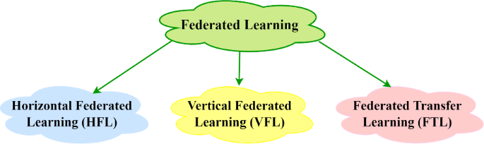

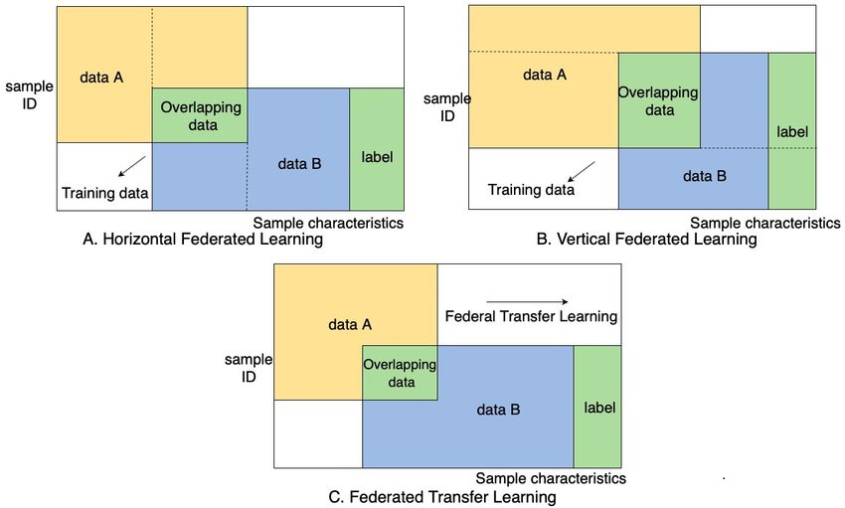

1. Horizontal Federated Learning
- Same feature space, different users
- Example: Mobile keyboards across users
2. Vertical Federated Learning
- Same users, different features
- Example: Bank + e-commerce sharing encrypted features
3. Federated Transfer Learning
- Different users + different features
- Uses transfer learning techniques

Privacy Techniques
Federated learning is privacy-preserving, but not perfectly private. It often combines:
1. Differential Privacy
Adds noise to updates to prevent reconstruction of data.
2. Secure Aggregation
Server only sees the sum of updates, not individual ones.
3. Homomorphic Encryption
Allows computation on encrypted data.

Optimization Challenges
1. Non-IID Data
Data across clients is not identically distributed.
- Example: Different typing styles, different medical records
- Causes instability in training

2. Unbalanced Data
Some clients have more data than others.

3. System Heterogeneity
- Devices vary in:
  - CPU power
  - Battery
  - Connectivity

4. Communication Bottleneck
- Sending model updates is expensive
- Especially for large models

Advanced Techniques
1. Gradient Compression
Reduces communication size via:
- Quantization
- Sparsification
2. Personalization
- Global model + local fine-tuning
- Each client adapts model to its data
3. Meta Learning in FL
- Learn a model that can quickly adapt to each client
4. Federated Averaging Variants
- FedProx: handles non-IID data better
- Scaffold: reduces client drift
Real-World Applications
Healthcare
Hospitals collaboratively train models without sharing patient data.
Finance
Banks detect fraud without exposing sensitive customer data.
Mobile Devices
- Predictive keyboards
- Voice recognition
- Next-word prediction

Security Risks
Even though data isn’t shared, attacks are still possible:
1. Gradient Leakage
Attackers may reconstruct data from gradients.
2. Poisoning Attacks
Malicious clients send fake updates to corrupt the model.
3. Inference Attacks
Infer whether a data point was part of training.

Advantages vs Limitations
Advantages
- Strong privacy protection
- Reduced data transfer
- Regulatory compliance
- Enables collaboration across organizations
Limitations
- Complex system design
- Communication overhead
- Slower convergence
- Vulnerable to certain attacks

References
1. https://cloud.google.com/discover/what-is-federated-learning
2. https://www.researchgate.net/figure/Classification-of-federated-learning-in-10-a-Horizontal-federated-learning-HFL_fig1_378809686
3. https://onlinelibrary.wiley.com/doi/10.1155/2021/8261663
4. https://www.youtube.com/watch?v=89BGjQYA0uE
5. https://www.geeksforgeeks.org/machine-learning/collaborative-learning-federated-learning/
6. https://media.springernature.com/lw685/springer-static/image/chp%3A10.1007%2F978-981-95-3543-9_21/MediaObjects/654870_1_En_21_Fig1_HTML.png
7. https://media.springernature.com/lw685/springer-static/image/art%3A10.1007%2Fs10115-024-02257-6/MediaObjects/10115_2024_2257_Fig8_HTML.png

